**Borrower name: Mdm. Chhot Sino and Miss Leang Mesa**

**Photo of borrower residential and Business premise**

**Photo taken on 12/04/2017 by Roeurn Sarak**

**Address: Phum Sampov Meas, Sakor commune, Kampong Svay district, Kampong Thom province.**

Location map:

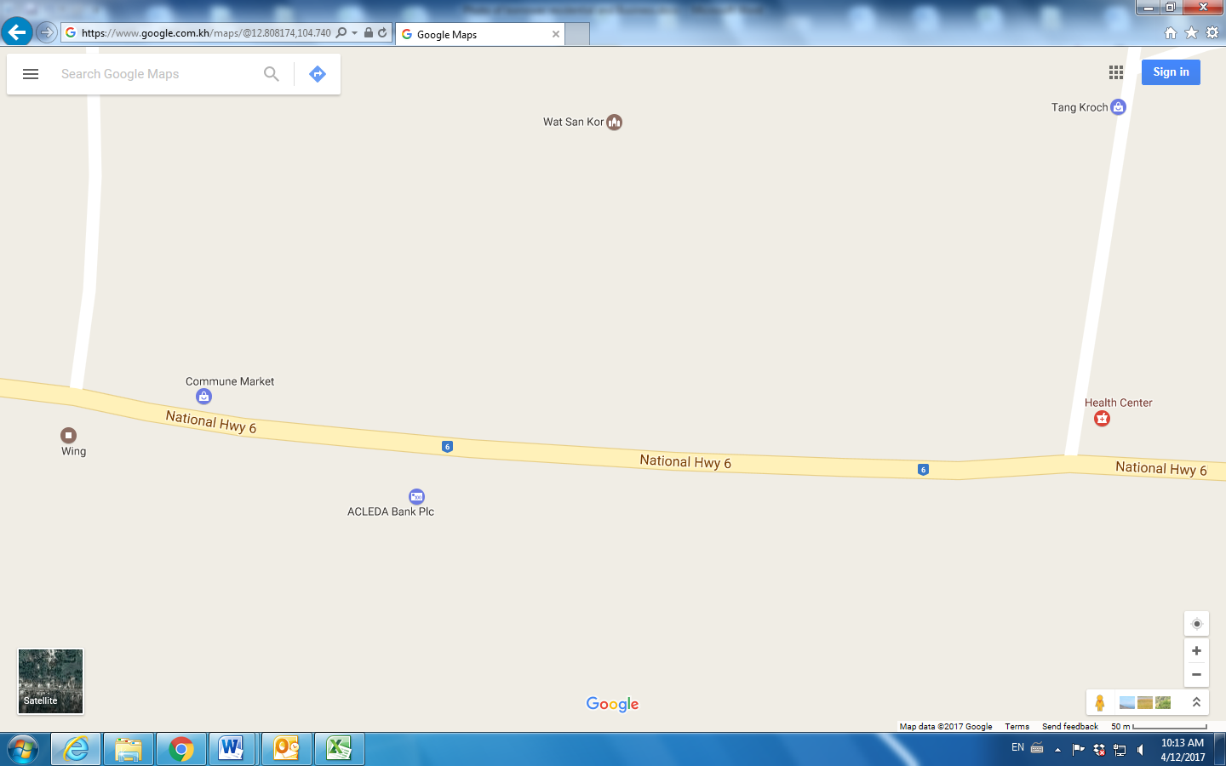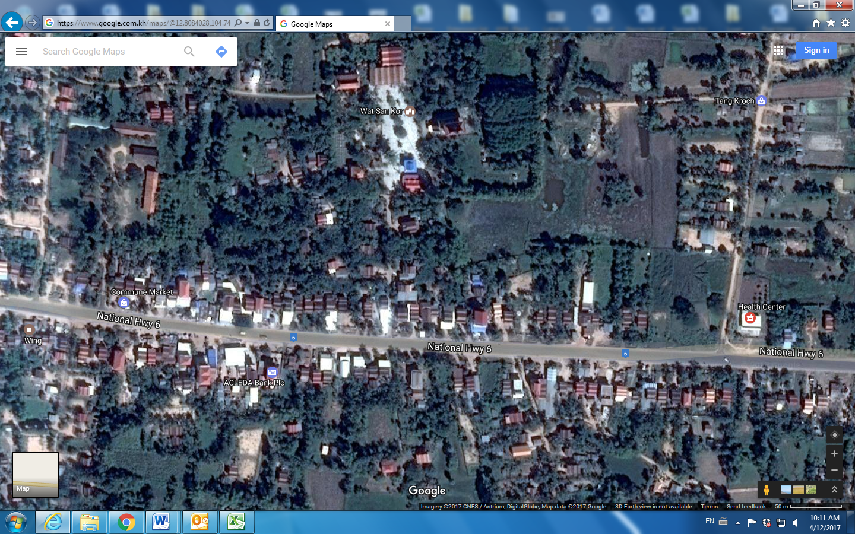

**Subject of borrower residential and Business premise**

